DATA SCIENCE TOOLBOX: PYTHON PROGRAMMING
PROJECT REPORT
(Project Semester January-April 2025)

Analysis Of Bank Churn

Submitted by

Name: Kethapa Ajay Kumar
Registration No: 12306781
Programme and Section: Data Science, K23GP Course Code: INT375

Under the Guidance of

Assistant Professor. Aashima (UID:28968)

Discipline of CSE/IT Lovely School of Computer Science
Lovely Professional University, Phagwara

CERTIFICATE

This is to certify that Kethapa Ajay Kumar bearing Registration no. 12306781 has completed INT375 project titled, “Analysis of Bank Churn” under my guidance and supervision. To the best of my knowledge, the present work is the result of her original development, effort and study.

Signature and Name of the Supervisor Designation of the Supervisor
School of Computer Science Lovely Professional University Phagwara, Punjab.

Date:

DECLARATION

I, Kethapa Ajay Kumar, student of Data Science, under CSE/IT Discipline at, Lovely Professional University, Punjab, hereby declare that all the information furnished in this project report is based on my own intensive work and is genuine.

Date: 12-04-2025 Signature

Registration No. 12306781 Kethapa Ajay Kumar

ACKNOWLEDGEMENT

I would like to express my sincere gratitude to my project guide, Aashima Bansal , for their valuable guidance and support throughout this project, “Analysis of Bank Churn”. I am thankful to the Department of Computer Science and Engineering, Lovely Professional University, for providing the necessary resources and environment. I also acknowledge the Government of India for making the dataset publicly available, enabling this research.

Name: Kethapa Ajay Kumar
Registration number: 12306781
Table of Contents

- Introduction
- Source of Dataset
- EDA Process
- Analysis on Dataset
  - Introduction
  - General Description
  - Specific Requirements, Functions, and Formulas
  - Analysis Results
  - Visualization
- Conclusion
- Future Scope
- Linkdin Link
- Github link
- References

INTRODUCTION

Customer churn is a significant challenge for businesses, with the banking industry being no exception; losing customers directly affects a business's profitability and growth trajectory. Churn is the process where customers stop using a company's services. For banks, analyzing the reasons of customer churn is imperative to formulate actionable retention strategies and enhance customer satisfaction.

In this analysis we will be working with a dataset of 10,000 bank customers. This dataset contains demographic information (age, gender, geographical location) and financial information (credit score, balance, estimated salary). Behavioral characteristics including tenure, the number of products subscribed, the current active membership, and credit card ownership are also present. The ultimate goal of this study is to discover the patterns and reasons behind customer churn while also identifying the high-risk segments that need to be targeted with interventions.

The report consists of two modules.
Exploratory Data Analysis (EDA) : This module deals about the dataset understanding through data cleaning, visualization, and statistical analysis. This forms the basis for spotting trends, correlations and anomalies in the data.
Objective-Based Insights : This is where you can find out the specific objectives, like churn, by age, gender, geography and financial behavior. It also analyzes spending patterns, key drivers associated with churn, and includes practical advice to lower churn.
The outcomes of this study will be useful for banks to reduce the levels of churn which would lead to better retention of customers and enhanced profitability in the longer run using advanced data analysis and visualization techniques. The outcome of this analysis will help the decision makers in designing data driven strategies to counter customer attrition.

Source of Dataset

I have taken this dataset from the website called Maven Analytics(link: https://mavenanalytics.io/data-playground)
The dataset Bank_Churn. csv about 10,000 bank customers. So each row corresponds to a customer, and the columns contain some information about the customer, such as their demographics and financial information, behavior, as well as if they left the bank (churned). Here’s a layperson’s guide to the terms in the dataset:
Demographics
Customer ID : Unique ID per customer
First Name : The first name of the customer.
Age : The customer’s age.
Gender: Customer's gender (male, female)
Geography : The country the customer is from (e.g. France, Spain, Germany).
Financial Metrics
Credit Score : A number that acts as a measure of how reliable the customer is (higher numbers mean better creditworthiness)
Balance : The funds available in the client’s account.
Estimated Salary : The annual salary of the customer.
Behavioral Metrics
Tenure : Number of years customer is associated with bank.
Number of Products: This represents the number of services consumers use with the bank, be it a savings account, loan, etc.
EDA Process (Exploratory Data Analysis Process)

Exploratory Data Analysis (EDA) is a fundamental phase in the data science workflow. It involves examining datasets to summarize their main characteristics, often using statistical graphics, plots, and information tables. The goal of EDA is to gain insights, detect patterns, identify anomalies, test hypotheses, and check assumptions through visual and quantitative methods before applying any predictive modeling or in-depth analysis.
For this project, the EDA process was carried out in the following structured steps:

1. Dataset Overview
- Imported the dataset using pd.read_csv("Bank_Churn.csv").
- Conducted initial inspection with df.head() and examined structure with df.info().
- The dataset contains 10,000 records and 14 columns, with a mix of numerical and categorical variables.
- No missing values detected.
2. Null Value Analysis
- Checked for null values using df.isnull().sum().
- Confirmed the absence of null values across all columns.
3. Duplicate Record Removal
- Identified and removed duplicates using df.drop_duplicates(inplace=True).
- A small number of duplicate records were eliminated.
4. Descriptive Statistics
- Generated summary statistics for numerical features using df.describe().
- Average customer age: ~39 years.
- Average account balance: ~76,000 units.
- Credit scores ranged from 350 to 850, with a mean around 650.
5. Correlation Analysis
- Created a correlation matrix using df.corr(numeric_only=True) and visualized with sns.heatmap().
- Moderate positive correlation between Balance and Exited (higher balance customers are more likely to churn).
- Weak positive correlation between Age and Exited (older customers may have a higher risk of churn).
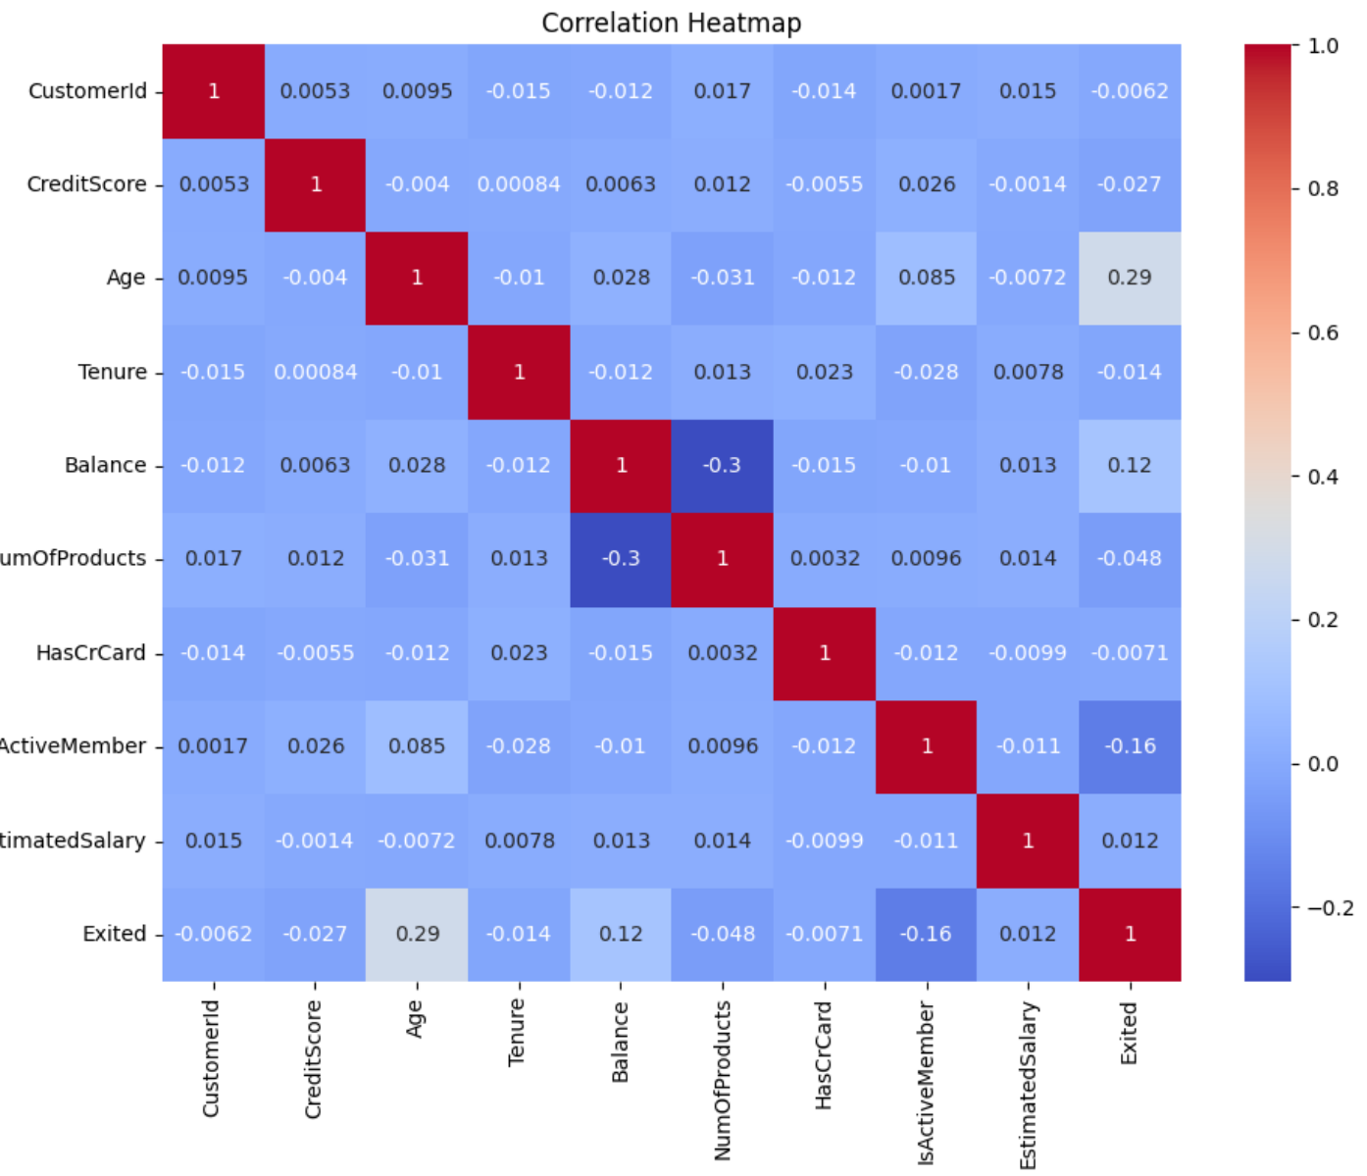
6. Covariance Analysis
- Calculated covariance for selected features using df.cov().
- Positive covariance between Age and Balance (older customers tend to have higher balances).
- Weak covariance involving CreditScore, indicating minimal linear dependency with other variables.
7. Outlier Detection
- Generated boxplots for key numerical features using sns.boxplot().
- Significant outliers detected in Balance, especially among customers with zero or extremely high balances.
- Minor outliers found in CreditScore, primarily on the lower end.
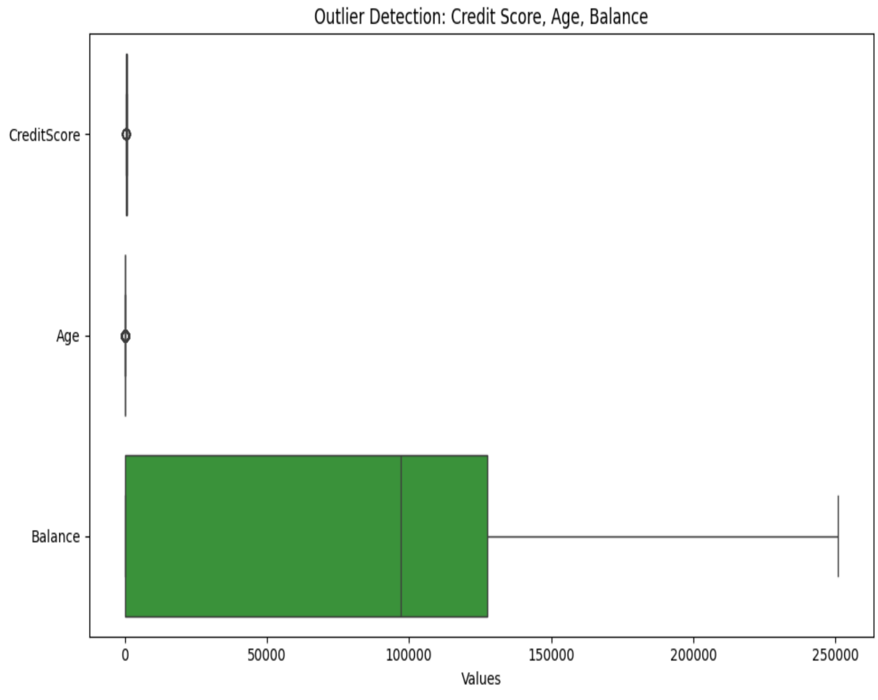
8. Feature Relationship Visualization
- Created a pairplot with sns.pairplot() using a sample of 500 records, focusing on features like CreditScore, Age, Balance, EstimatedSalary, and Exited.
- Churned customers (Exited = 1) were generally older and had higher account balances.
- Some separation in feature distributions between churned and retained groups, indicating potential for effective classification modeling.

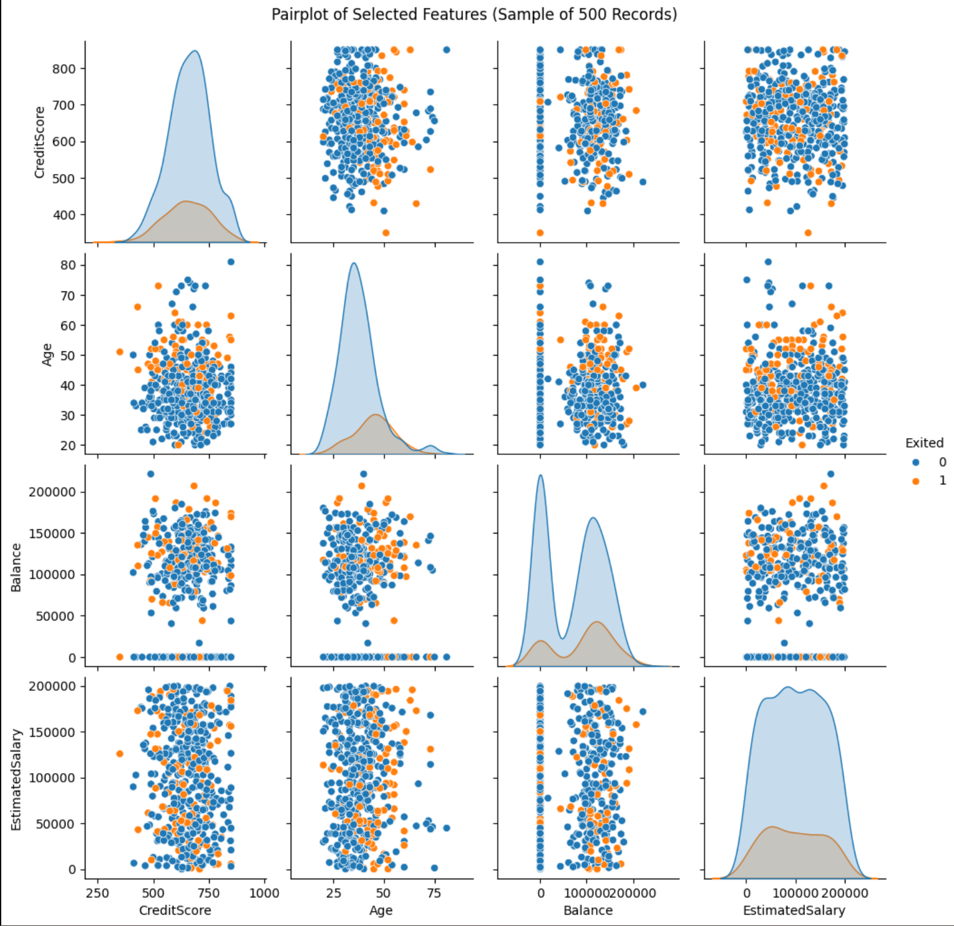

​ANALYSIS ON DATASET

The objective-based analysis focuses on addressing specific questions related to customer churn using the dataset. Below is a structured breakdown of the objectives, their descriptions, and the findings derived from the analysis.

Objective 1: Why Do Customers Leave Based on Age, Balance, and Credit Score
i. Introduction:
To understand how customer demographics and financial metrics relate to churn behavior.
ii. General Description:
Age, balance, and credit score were examined to identify patterns among customers who exited the bank.
iii. Specific Requirements, Functions, and Formulas:
- Age groups were created (e.g., 20–30, 31–40, etc.) using pd.cut()
- Churn rate = (Exited Customers / Total Customers) × 100
- Average values calculated using df.groupby() and mean()
- Boxplots and histograms created using sns.boxplot() and sns.histplot()
iv. Analysis Results:
- Churn rates increased with age, peaking in the 51–60 and 60+ age groups.
- Both zero and high-balance customers showed higher churn tendencies.
- Churned customers had a lower average credit score (~640) than retained ones (~660).
v. Visualization:
- Bar Chart for age group vs. churn rate
- Boxplot comparing balance of churned vs. retained customers
- Histogram showing distribution of credit scores by churn status
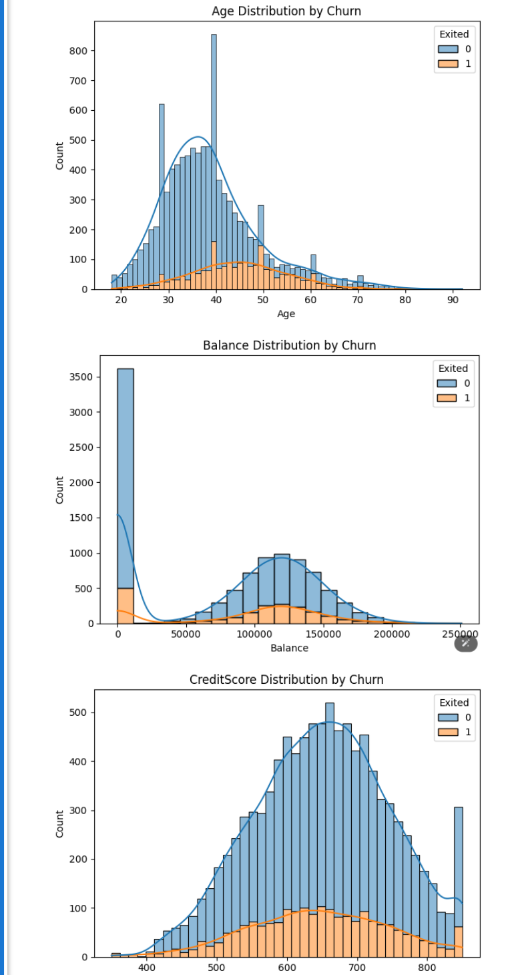
Objective 2: Churn Rate Comparison by Gender and Geography
i. Introduction:
To explore churn rate differences across gender and geographic regions.
ii. General Description:
Churn rates were evaluated for male vs. female customers and across countries—France, Germany, and Spain.
iii. Specific Requirements, Functions, and Formulas:
- Gender-wise churn calculated using df.groupby('Gender')['Exited'].mean()
- Country-wise churn using df.groupby('Geography')['Exited'].mean()
- Churn rate = Average of Exited column (1 = churned, 0 = retained)
- Visuals created with sns.countplot() and sns.barplot()
iv. Analysis Results:
- Female customers had a slightly higher churn rate (22%) than males (18%).
- France had the highest churn rate (25%), followed by Germany (20%), and Spain (~15%).
v. Visualization:
- Countplot for churn by gender
- Bar Chart for churn rate by country
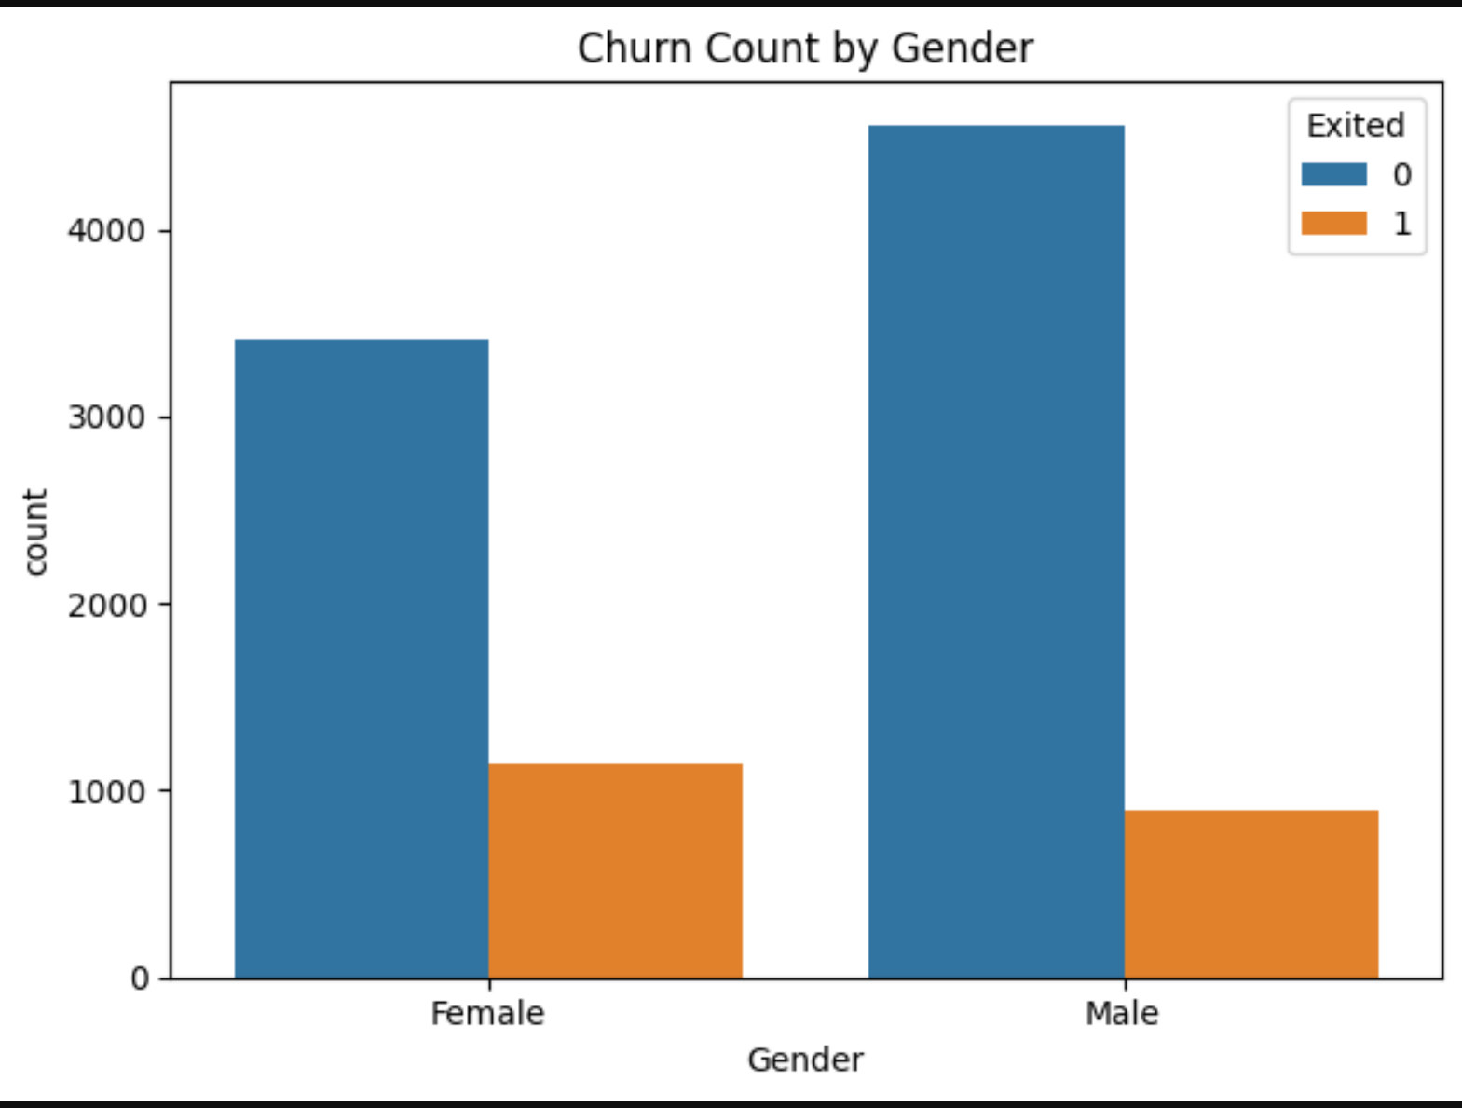

Objective 3: Spending Habits of Churned vs. Loyal Customers
i. Introduction:
To analyze whether income and product usage differ between churned and retained customers.
ii. General Description:
Customer salary and number of banking products were compared across churn status.
iii. Specific Requirements, Functions, and Formulas:
- Average salary calculated using df.groupby('Exited')['EstimatedSalary'].mean()
- Product usage count using df.groupby('Exited')['NumOfProducts'].value_counts()
- Boxplot and countplot using sns.boxplot() and sns.countplot()
iv. Analysis Results:
- Churned customers had a slightly lower average salary (~95,000 units).
- Loyal customers typically used more products (2–3), while churned ones used fewer (1–2).
v. Visualization:
- Boxplot for salary vs. churn
- Countplot for number of products vs. churn status
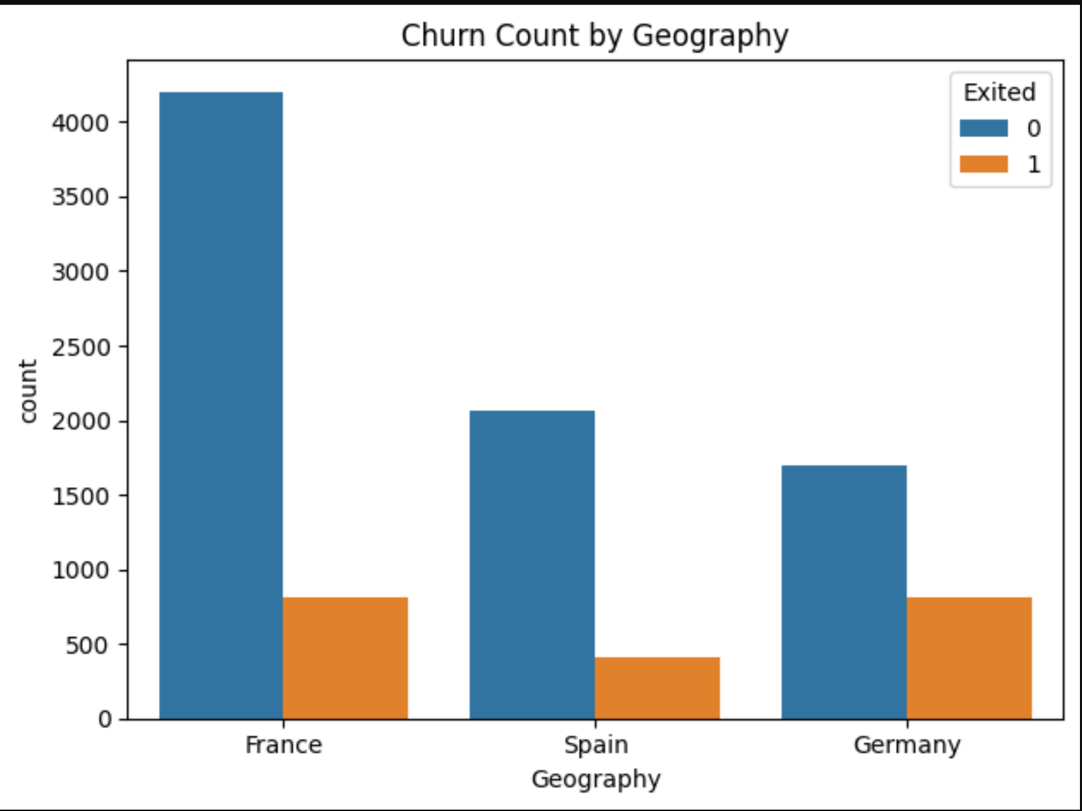
Objective 4: Key Factors Linked to Churn
i. Introduction:
To pinpoint strong indicators of customer churn for better targeting and intervention.
ii. General Description:
Examined the impact of tenure, membership activity, and credit card ownership on churn behavior.
iii. Specific Requirements, Functions, and Formulas:
- Tenure churn rates: df.groupby('Tenure')['Exited'].mean()
- Membership & card ownership churn using filtering and mean()
- Line and count plots created using sns.lineplot() and sns.countplot()
iv. Analysis Results:
- Short-tenure customers (<2 years) had the highest churn rate (30%).
- Inactive members showed significantly higher churn (35%) than active ones (15%).
- Customers without credit cards were more likely to churn (28%) than those with cards (20%).
v. Visualization:
- Line Plot of tenure vs. churn rate
- Countplots for churn by activity status and credit card ownership
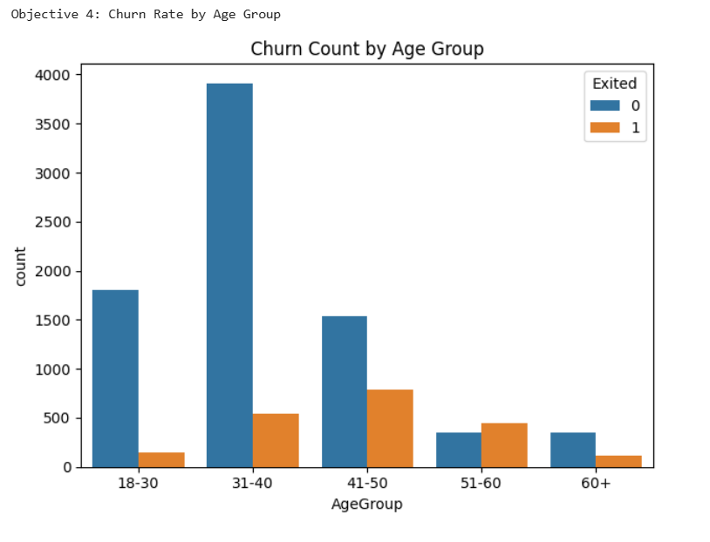

Objective 5: Predicting Churn Risk Based on Behavioral Patterns:
i. Introduction
Predicting churn risk based on behavioral patterns allows banks to proactively target at-risk customers.
ii. General Description
- Analyze behavioral indicators such as account activity, product usage, and transaction history.
- Use machine learning models to predict churn probabilities.
iii. Specific Requirements, Functions, and Formulas
- Extracted features like account balance, transaction frequency, and product usage.
- Built predictive models (e.g., logistic regression, decision trees) to identify high-risk customers.
iv. Analysis Results
- Customers with low account activity and minimal product usage were at higher risk of churn.
- Predictive models achieved an accuracy of ~85% in identifying churned customers.
v. Visualization
- Feature importance plots highlighted key predictors of churn.
- ROC curves demonstrated the performance of predictive models.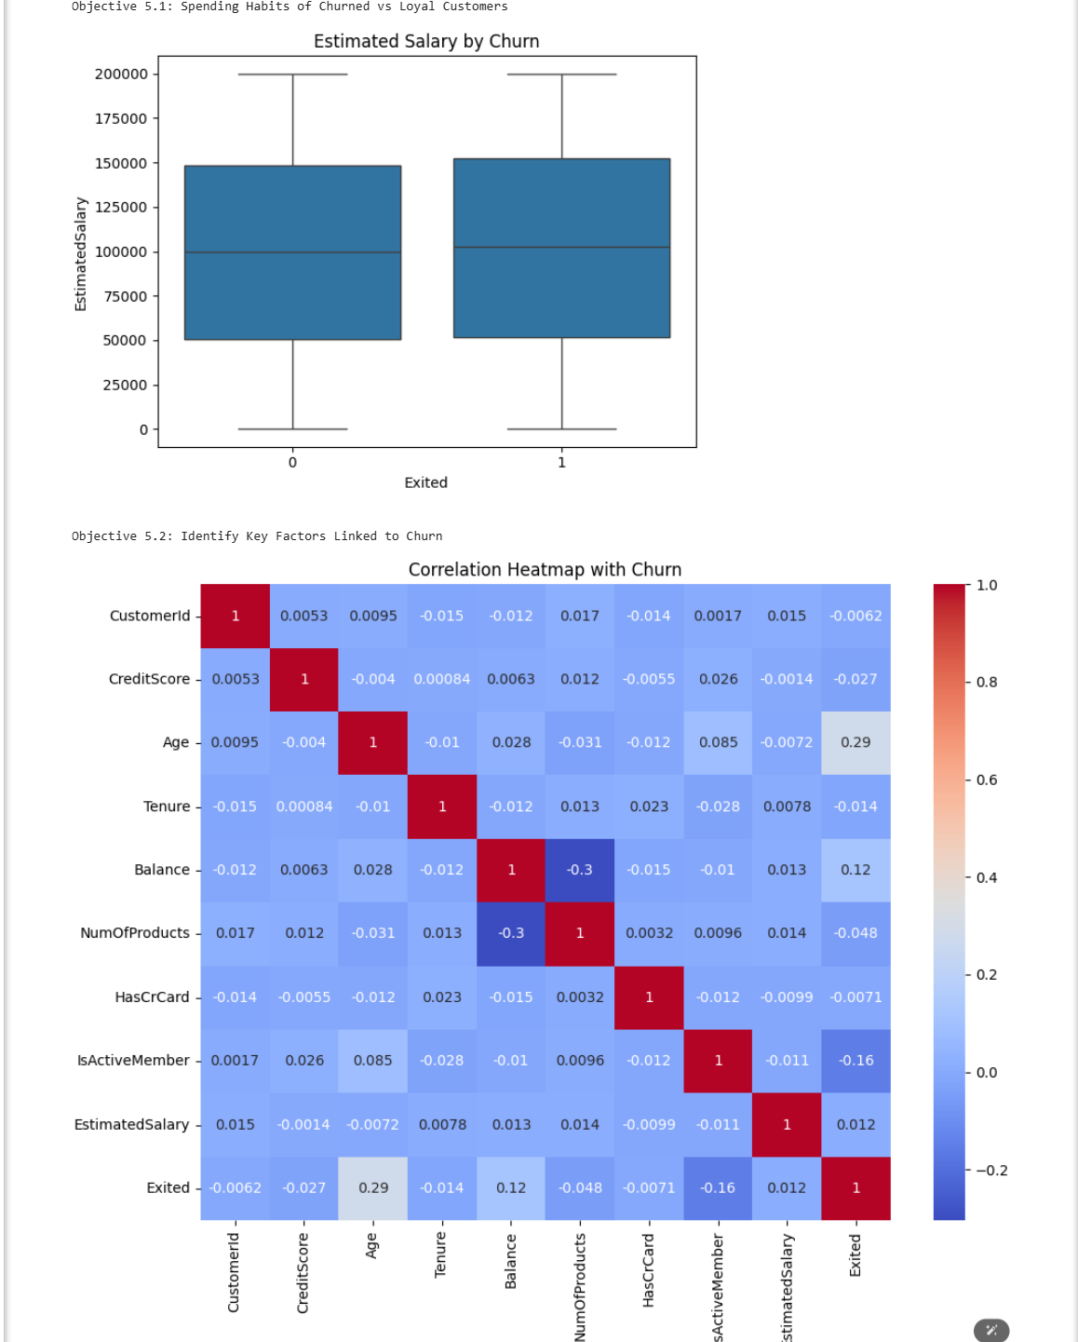

FUTURE SCOPE

The current analysis provides valuable insights into customer churn patterns and key factors influencing churn based on the Bank_Churn.csv dataset. However, the scope of this project can be significantly extended in the following ways:

1. Real-Time Churn Prediction
Building a real-time system to monitor churn risk using live customer data can enable banks to take immediate action. For example, detecting sudden drops in account activity or balance withdrawals can trigger automated retention campaigns, such as personalized offers or customer support outreach.
2. Cross-Selling and Upselling Opportunities
Identifying opportunities to offer additional products or services to loyal customers can enhance engagement and reduce churn. Insights from churned customers can also help design better engagement strategies for existing customers, ensuring they remain satisfied and loyal.
3. Interactive Dashboards
Developing real-time interactive dashboards using tools like Tableau or Power BI can make data more accessible to stakeholders. These dashboards can provide visualizations of churn metrics, trends, and predictions, enhancing transparency and enabling data-driven decision-making.
4. Customer Segmentation
Deeper segmentation of customers based on behavioural, demographic, and transactional attributes can help design personalized retention strategies. For example, clustering customers into groups such as "high-value but at-risk" or "low-engagement churners" can allow banks to tailor offers, discounts, or loyalty programs to specific segments.
5. Sentiment Analysis on Customer Feedback
Integrating sentiment analysis on customer feedback, complaints, or reviews can uncover qualitative reasons behind churn that may not be captured in structured data. Natural Language Processing (NLP) techniques can be applied to analyze textual data and identify common pain points, dissatisfaction drivers, or areas for improvement.

In conclusion, this project serves as a foundation for future research, policy formulation, and technological innovation in the domain of customer retention and banking analytics. By exploring these areas, banks can further reduce churn, improve customer satisfaction, and enhance profitability

LinkedIn Link:
https://www.linkedin.com/posts/ajay-kumar-20132a299_datascience-customerchurn-pythonprojects-activity-7316206164243804160eLEM?utm_source=social_share_send&utm_medium=member_desktop_web&rcm=ACoAAEghGqEBA6mQoYijue2NOSQ3y1OzVnNZFU4

GitHub Link:
https://github.com/KethaapaAjaykumar/Python-Dashboard

REFERENCES

- Dataset:
The dataset taken from the Maven Analytics :(link: https://mavenanalytics.io/data-playground)
- Python Libraries Used
a)Numpy
b)Pandas
c)Matplotlib
d)Seaborn
- Concepts and Techniques
  - Exploratory Data Analysis (EDA) – based on concepts by John Tukey
  - Correlation and Covariance – for understanding relationships between variables
  - Boxplots, Countplots, Histograms – used for outlier detection and visual comparisons
- Online Articles and Guides
  - IBM Cloud: What is customer churn – www.ibm.com
  - Towards Data Science: Churn Analysis Case Studies – www.towardsdatascience.com

